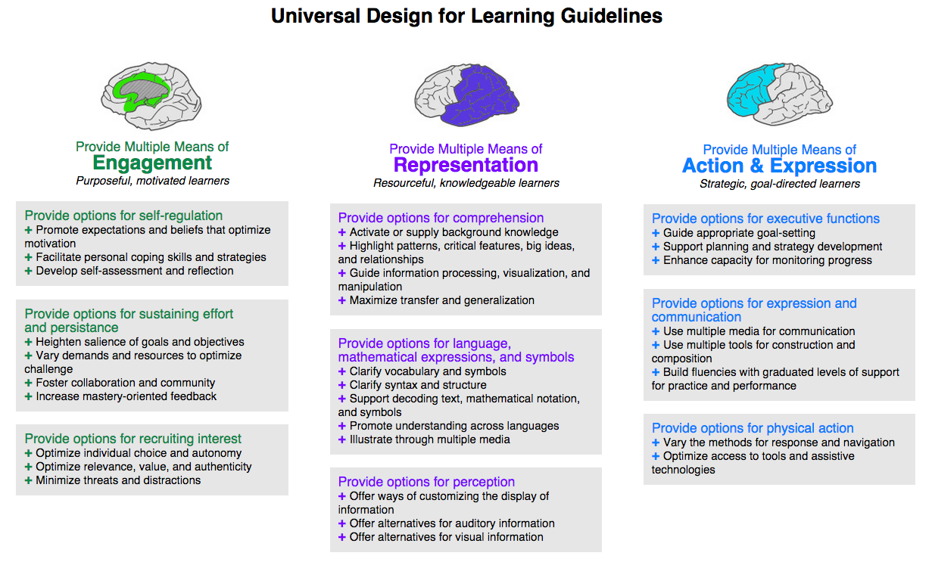
Source: http://www.udlcenter.org/print/371

